**Steps for Initiating InfraonIMS Admin console Services:**

* The first step is to get the services to run in the user’s setup. To do that, navigate to the below mentioned path in Admin console (:8000):

From the Main menu panel, select Management-> System Status-> Remote Process Status.

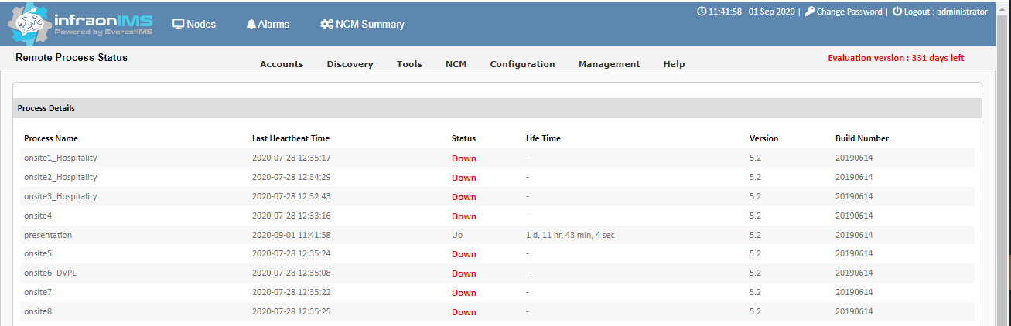

* Ensure that all processes will be listed as mentioned above
* Next, login to the NMS server (via) Putty.
* Use the below mentioned commands.
  + ***service <process_name> start/stop/status***
  + Use start,stop and status accordingly to start or stop the services.

**Note:** Replace the process name as per your scenario.

**Steps for Initiating InfraonIMS Portal Services:**

* Execute the below commands.
  + ***service httpd start/stop/status***
  + ***service redis start/stop/status***
  + ***service celeryworkerservice start/stop/status***
  + ***service celerybeatservice start/stop/status***

**Note**:After initiating all the services,If you are having issues with InfraonIMS, use the below commands:

* + ***service firewalld stop***
  + ***setenforce 0***

**Command for automating the services (start service) after the server reboot:**

* + ***chkconfig <service_name> on***

**For permanently disabling the firewalld and selinux use the below commands:**

* + ***systemctl disable firewalld***
  + ***vi /etc/selinux/config***
  + ***Replace the Enable key to disabled***

**Steps for Starting Everest Trisul console Services:**

Once the server is rebooted, try accessing Trisul server from browser and if it is accessible, try the below steps:

* Login with admin privileges and make it up hub and then probe

If not accessible login into Trisul server (via Putty) and execute the below commands

* + ***service webtrisuld status***
  + ***service trisul-hub0-context0 status***
  + ***service trisul-hub status***
  + ***service trisul-probe status***